# Current Activities

The museum has a new, young assistant in the museum. He is a full-time IBM employee but is very keen to spend his lunchtimes and some evenings helping out when and how he is able. He has already helped us out of a potential problem by collecting a 129 card punch / verifier from Darlington in his car.

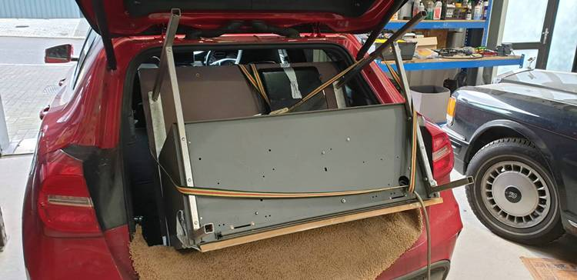The 129 was offered to us about 4 years ago. It was located in the Netherlands, but the offer came from someone in the UK who said he made regular visits there and would bring it over. Then along came Covid, and we weren’t sure if or when we might get the machine. A short while ago we got a message that the machine was now in the UK, in the back of a car somewhere in North Yorkshire, and how would we like to get it down to Hursley.

As it turned out, our new man was possibly going to Northumberland on business, but not yet confirmed. If it came off he would collect it for us. I made contingency plans – I phoned Jim Austin to ask if he might be able to find a small corner for temporary storage, being fully aware his space is at a premium.

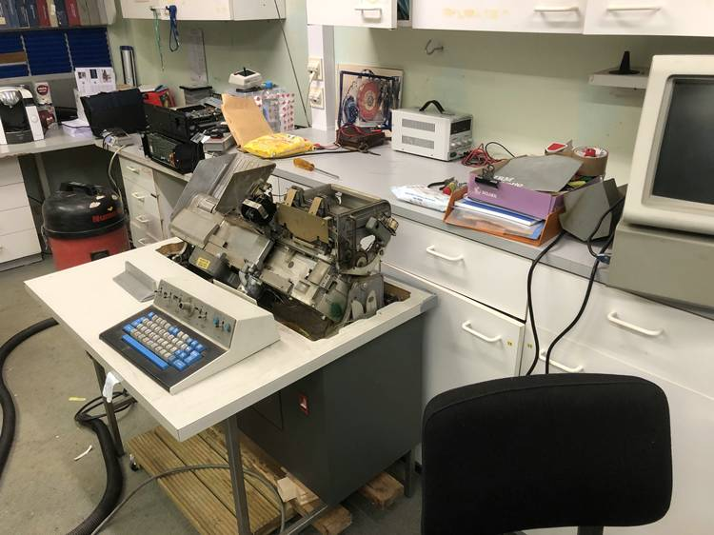Jim agreed, meanwhile the trip was confirmed and so the 129 was collected and brought back to Hursley.

It was a bit of a tight fit, but without legs and top cover it did just go in.

The 129 is in a rather filthy state, so he who collected it is now working on cleaning it up. Mechanically it is looking good, it remains to be seen if the logic gate has survived the years in storage.

We are continuing to work through the PCs and PS2s we received recently. Several machines are now in good working order. Where we have been unsuccessful is generally down to power supply issues. Unless it’s obvious, like an exploded capacitor, it is difficult to fault find without wiring diagrams.

The 3279, the first colour terminal, developed in Hursley, joined the 3270 family in 1979. Our display model was powered up many years ago to the accompaniment of a very bad smell and otherwise nothing. We finally decided it was time we tried to get it working and so once again faced the inevitable power supply problem. A bank of 12 electrolytic capacitors was looking decidedly unwell, so the first job was to replace them. The photos show before and after.

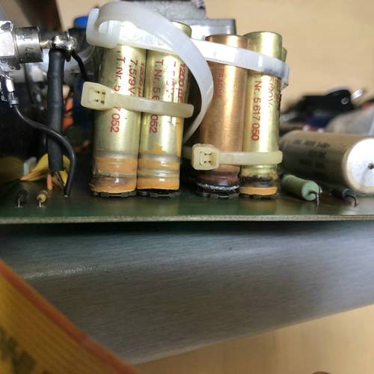 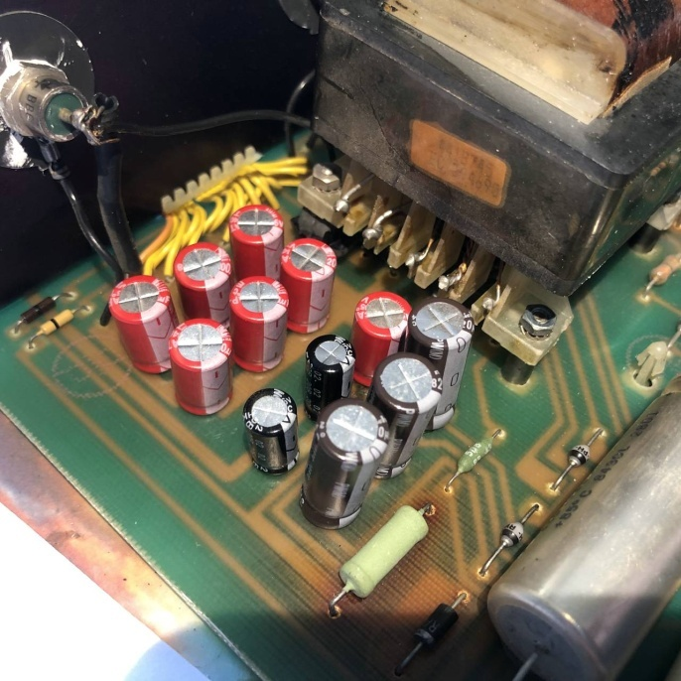

Unfortunately we still have problems, although there are at least signs of life now. This may still be a power supply issue as there are multiple voltages involved. However the solid green line at the bottom of the screen is fixed, and below which various status indicators would be displayed. The other line suggests a vertical driver issue, as it is a few mm deep and showing flickering.

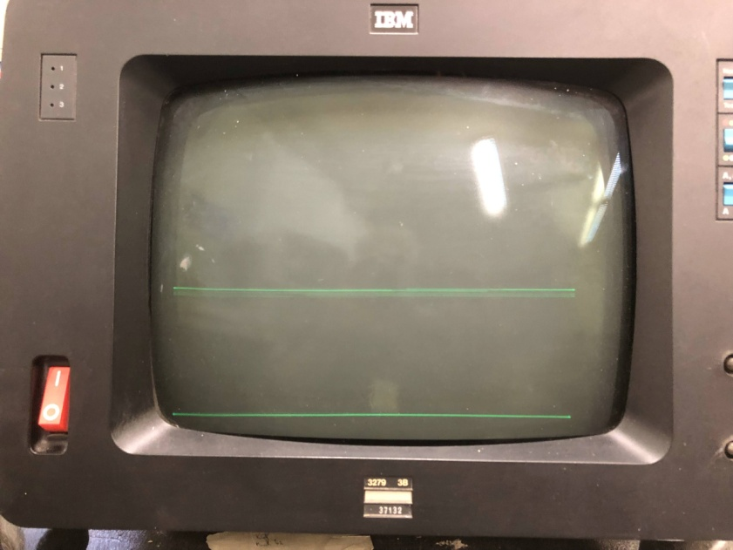As we don’t have circuit diagrams it is again difficult to trace faults. The analogue card shows no obvious signs of distress. We do have another 3279, a 110 volt version. However it is of a completely different design and layout.

Our 3278 mono display, which we obtained from Jim Austin, also has virtually no vertical output. That is next on the list, with the hope we can eventually connect these two machines to our 3174 controller with some sort of demo.

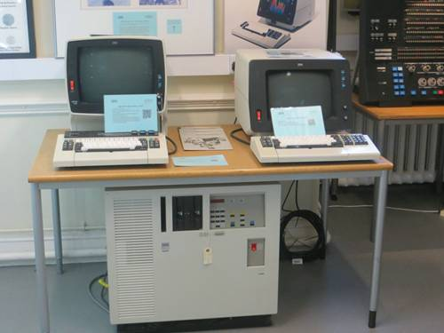The 3174 looks like it may be in good working order. It does power up, and IML from diskettes, then stops with a code that suggests configuration is incorrect. We did have a problem tracking down the diskettes; they had migrated to the very back of a cupboard full of other diskettes. None of us has worked with 3174, so we’ll need to learn how to configure it. As a third contender for attachment to the 3174 we would like to build a PC with co-ax adapter card and 3270PC software.